**Module: R3: DLD + DSD**

**Section:** Sequential Circuits **Task:** Final Project

**Design Problem**

**FIFO Design**

* **Question: Design an Asynchronous active low reset FIFO:**

1. **Schematic Diagram:**

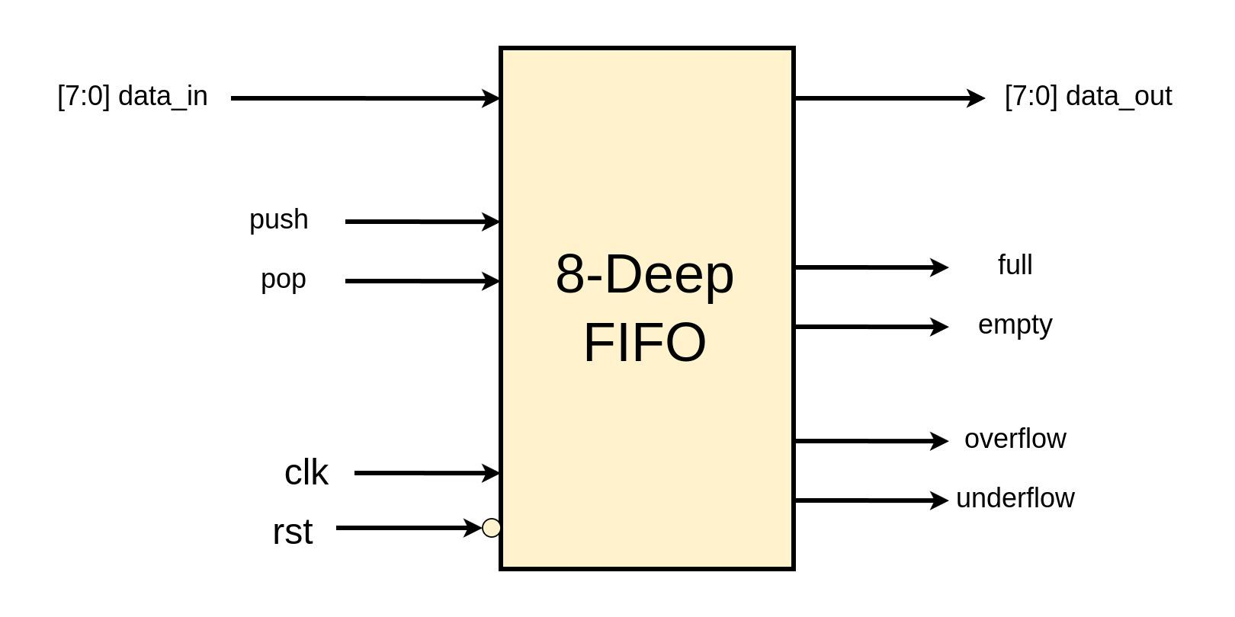

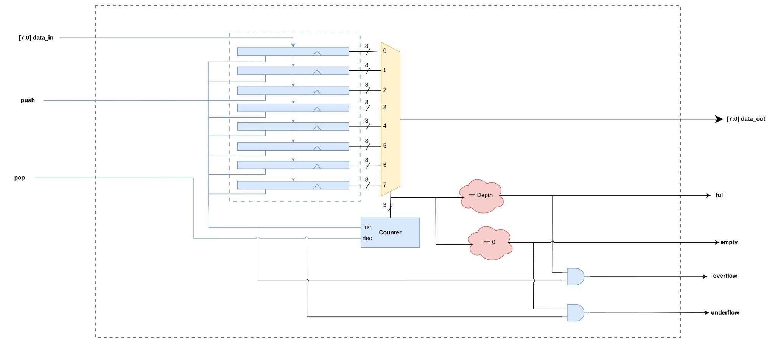

1. **FSM Diagram:**

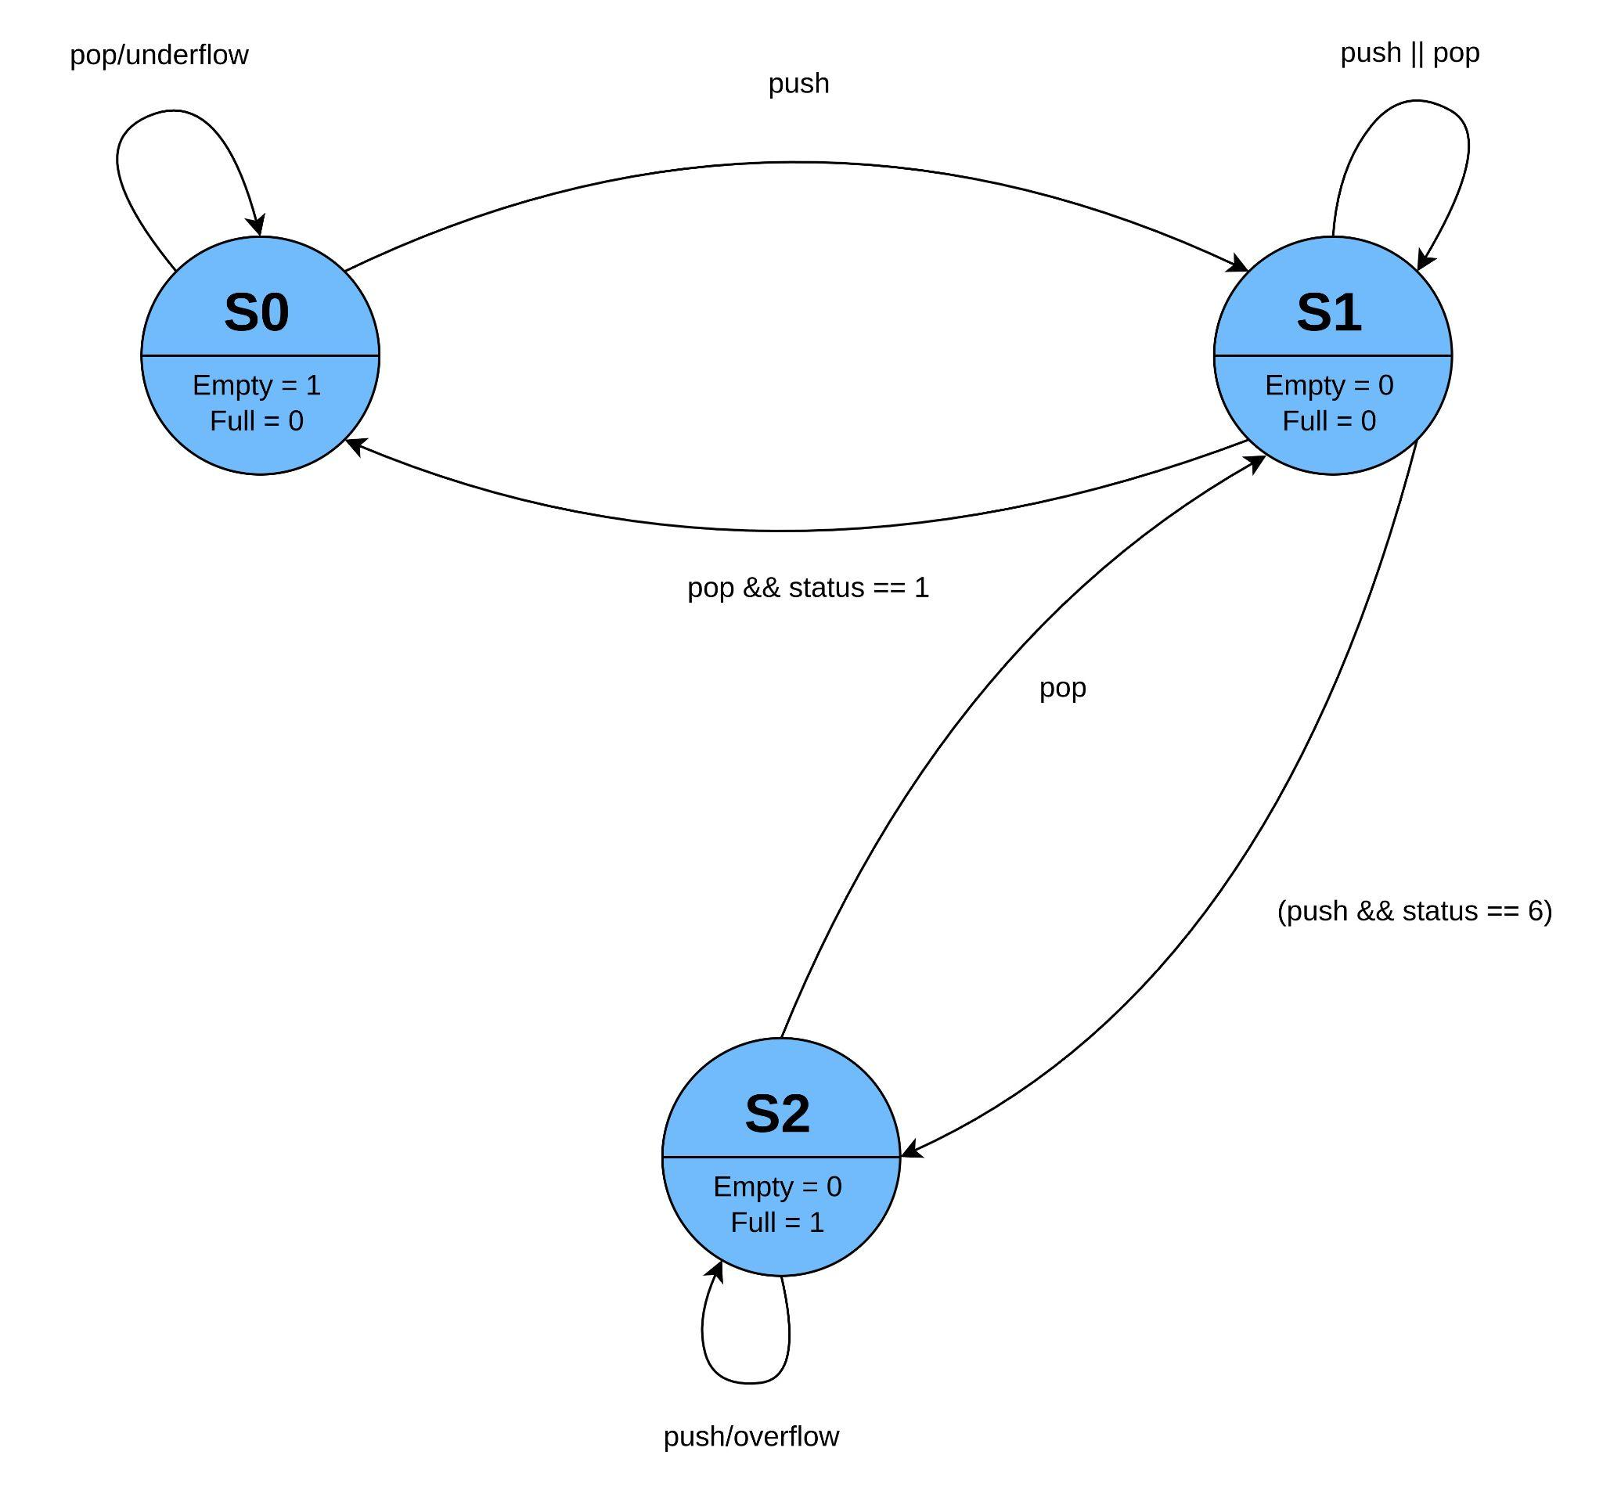

1. **Verilog Code:**

module fifo #(parameter DATA_SIZE = 8, parameter ADDRESS_SIZE = 3)

(input clk, rst, push, pop,

input [DATA_SIZE-1:0] data_in,

output reg [DATA_SIZE-1:0] data_out,

output reg full, empty,

output reg overflow, underflow);

localparam ADDRESS_DEPTH = 2**ADDRESS_SIZE;

reg [DATA_SIZE-1:0] memory [ADDRESS_DEPTH-1:0];

reg [ADDRESS_SIZE-1:0] read_ptr, write_ptr;

reg [ADDRESS_SIZE:0] status; // Extra bit for distinguishing full and empty

//Empty & Full Logic

assign empty = (status == 0);

assign full = (status == ADDRESS_DEPTH);

// Overflow & Underflow Logic

assign overflow = (push && full);

assign underflow = (pop && empty);

// Sequential logic for write and pointer updates

always @(posedge clk or negedge rst) begin

if (!rst) begin

// Reset logic

read_ptr <= 0;

write_ptr <= 0;

status <= 0;

end else begin

if (push && pop) begin

// If both push and pop occur at the same time

if (!full && !empty)

begin

memory[write_ptr] <= data_in; // Perform write

write_ptr <= write_ptr + 1;

read_ptr <= read_ptr + 1;

end

else if (full) begin

read_ptr <= read_ptr + 1;

status <= status - 1;

end

else if (empty) begin

memory[write_ptr] <= data_in;

write_ptr <= write_ptr + 1;

status <= status + 1;

end

end else if (push && !full) begin

memory[write_ptr] <= data_in;

write_ptr <= write_ptr + 1;

status <= status + 1;

end else if (pop && !empty) begin

read_ptr <= read_ptr + 1;

status <= status - 1;

end

end

end

// Combinational logic for immediate read

always @(*) begin

if (push && pop) begin

if (!full && !empty)

begin

data_out = memory[read_ptr]; // Perform read

end

else if (full) begin

data_out = memory[read_ptr];

end

end

else if (pop && !empty ) begin

data_out = memory[read_ptr]; // Perform read immediately

end else begin

data_out = 'bx; // X value when pop is not active or FIFO is empty

end

end

endmodule

1. **Testbench:**

module tb_fifo;

// Parameters

parameter DATA_SIZE = 8;

parameter ADDRESS_SIZE = 3;

localparam ADDRESS_DEPTH = 2**ADDRESS_SIZE;

// Signals

reg clk, rst, push, pop;

reg [DATA_SIZE-1:0] data_in;

wire [DATA_SIZE-1:0] data_out;

wire full, empty, overflow, underflow;

integer i;

// Instantiation

fifo #(DATA_SIZE, ADDRESS_SIZE) uut (

.clk(clk),

.rst(rst),

.push(push),

.pop(pop),

.data_in(data_in),

.data_out(data_out),

.full(full),

.empty(empty),

.overflow(overflow),

.underflow(underflow)

);

// Clock generation

always #5 clk = ~clk;

// Testbench logic

initial begin

$dumpvars;

// Initialize signals

clk = 0;

rst = 1;

push = 0;

pop = 0;

data_in = 0;

// Reset the FIFO

@(posedge clk);

rst = 0;

@(posedge clk);

rst = 1;

@(posedge clk);

// Test case: Push to full

$display("Test case: Push to full");

for (i = 0; i < ADDRESS_DEPTH; i = i + 1) begin

@(posedge clk);

push = 1;

data_in = i;

end

@(posedge clk);

push = 0;

@(negedge clk)

if (!full) $display("Error: FIFO should be full");

else $display("Passed");

// Test case: Pop to empty

$display("Test case: Pop to empty");

for (i = 0; i < ADDRESS_DEPTH; i = i + 1) begin

@(posedge clk);

pop = 1;

end

@(posedge clk);

pop = 0;

@(negedge clk)

if (!empty) $display("Error: FIFO should be empty");

else $display("Passed");

// Test case: Simultaneous push and pop

for (i = 0; i < ADDRESS_DEPTH; i = i + 1) begin

@(posedge clk);

push = 1;

pop = 1;

data_in = i;

end

@(posedge clk);

push = 0;

pop = 0;

// Test case: Overflow

$display("Test case: Overflow");

for (i = 0; i < ADDRESS_DEPTH; i = i + 1) begin

@(posedge clk);

push = 1;

data_in = i;

end

@(posedge clk);

push = 1;

@(posedge clk);

push = 0;

if (!overflow) $display("Error: FIFO should have overflowed");

else $display("Passed");

// Test case: Underflow

$display("Test case: Underflow");

for (i = 0; i < ADDRESS_DEPTH; i = i + 1) begin

@(posedge clk);

pop = 1;

end

@(posedge clk);

pop = 1;

@(posedge clk);

pop = 0;

if (!underflow) $display("Error: FIFO should have underflowed");

else $display("Passed\n");

// End of test

$display("Congratulations, All test cases are now passing\n");

$finish;

end

endmodule

1. **Output:**

